Ex:no:9 | MINI PROJECT – TOURISM ANALYTICS
Date:

Domain and Problem Statement
Domain
Tourism Analytics

Problem Statement
The tourism industry generates large amounts of data related to tourists, destinations, hotels, bookings, travel duration, and revenue. Analyzing this data manually makes it difficult to identify popular destinations, booking trends, tourist preferences, hotel performance, and revenue patterns.

The proposed system uses SQL Server, Power BI, and Tableau to analyze tourism data and present it through interactive dashboards. This helps users understand important tourism patterns and make better data-driven decisions.

Dataset Description
The TourismDB database contains four related tables:

Tourists
Contains details about tourists.

Attribute Description
Tourist_ID Unique tourist identification number

Attribute Description
Tourist_Name Name of the tourist Age Age of the tourist
Gender Gender of the tourist
Country Tourist's country

Destinations
Contains information about tourist destinations.

Attribute Description Destination_ID Unique destination ID Destination_Name Name of the tourist destination Destination_Type Type of destination
State State where the destination is located Popularity_Rating Popularity rating of the destination

Hotels
Contains information about hotels.

Attribute Description Hotel_ID Unique hotel ID Hotel_Name Name of the hotel
Destination_ID Destination associated with the hotel Hotel_Category Category of the hotel
Room_Rate Average room rate

Bookings
Contains tourist booking and travel information.

Attribute Description Booking_ID Unique booking ID Tourist_ID Tourist identification number
Destination_ID Destination identification number Hotel_ID Hotel identification number Booking_Date Date of booking
Travel_Date Date of travel Trip_Duration Duration of the trip Booking_Cost Cost of the booking Travel_Type Type of travel
Booking_Status Status of the booking

The database contains 500 tourists and 500 booking records, along with destination and hotel information.

Data Source
The tourism dataset was created and stored in Microsoft SQL Server. Database: TourismDB
Database Management System: SQL Server 2025 The database was connected to:
- Microsoft Power BI Desktop for data preparation, modelling, DAX calculations, and dashboard creation.
- Tableau Desktop for visualization, calculated fields, parameters, and dashboard creation.

Data Preparation
The following data preparation steps were performed:

- Created the TourismDB database in SQL Server.
- Created four related tables:
  - Tourists
  - Destinations
  - Hotels
  - Bookings
- Defined primary keys for the tables.
- Defined foreign keys to establish relationships.
- Inserted tourism records into the tables.
- Connected the SQL Server database to Power BI.
- Loaded the required tables into Power BI.
- Established relationships between the tables.
- Checked the data types of fields such as dates, numbers, and categorical values.
- Created calculated fields/measures for tourism analysis.
- Prepared booking and travel-date information for trend analysis.
- Connected the same database to Tableau and established the required relationships.

Visualizations Used
Power BI
The following visualizations were created:

KPI Cards
  - Total Tourists
  - Total Bookings
  - Total Revenue
  - Average Booking Cost
  - Average Trip Duration

Line Chart
  - Monthly Booking Trend

Clustered Column Chart
  - Bookings by Destination
  - Revenue by Destination
  - Hotel-wise Bookings
  - Travel Type Analysis

Bar Chart
  - Tourist Distribution by Country

Donut Chart
  - Booking Status Distribution
  - Gender Distribution

Table
  - Booking Details

Drill-through
  - Tourist/Booking-level detailed analysis

Tableau
The following visualizations were created:

- Total Tourists
- Total Bookings
- Monthly Booking Trend
- Bookings by Destination
- Revenue by Destination
- Hotel-wise Bookings
- Tourist Country Distribution

A Tableau calculated field and parameter were also created for interactive analysis.

Calculations Performed
Power BI DAX Calculations

Total Tourists
Total Tourists = DISTINCTCOUNT(Bookings[Tourist_ID])

Total Bookings
Total Bookings = COUNT(Bookings[Booking_ID])

Total Revenue
Total Revenue = SUM(Bookings[Booking_Cost])

Average Booking Cost
Average Booking Cost = AVERAGE(Bookings[Booking_Cost])

Average Trip Duration
Average Trip Duration = AVERAGE(Bookings[Trip_Duration])

Confirmed Bookings
Confirmed Bookings = CALCULATE(
[Total Bookings], Bookings[Booking_Status] = "Confirmed"
)

Cancelled Bookings
Cancelled Bookings = CALCULATE(
[Total Bookings], Bookings[Booking_Status] = "Cancelled"
)

Tableau Calculation

Average Booking Cost
AVG([Booking_Cost])

A Revenue Threshold parameter was also created for interactive revenue-based analysis.

Insights Obtained
The dashboards provide the following important insights:

- The system contains 500 tourists and 500 bookings, allowing overall tourism activity to be monitored.
- The Monthly Booking Trend helps identify variations in the number of tourist bookings over time.
- Bookings by Destination helps identify destinations receiving a higher number of tourist bookings.
- Revenue by Destination helps compare the revenue generated by different destinations.
- Hotel-wise Bookings helps identify hotels receiving more bookings.
- Tourist Distribution by Country provides information about the geographical distribution of tourists.
- Gender Distribution provides a comparison of bookings across genders.
- Average Trip Duration helps understand the typical duration of tourist trips.
- Booking Status Analysis helps compare confirmed, cancelled, and other booking statuses.
- Travel Type Analysis helps identify the different types of travel preferred by tourists.
- The Booking Details drill-through page allows detailed tourist and booking-level information to be examined.

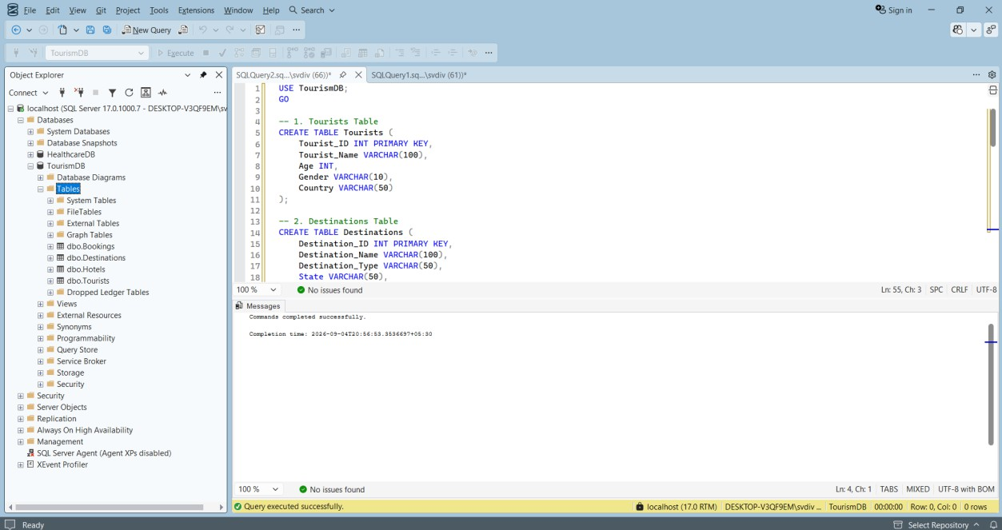
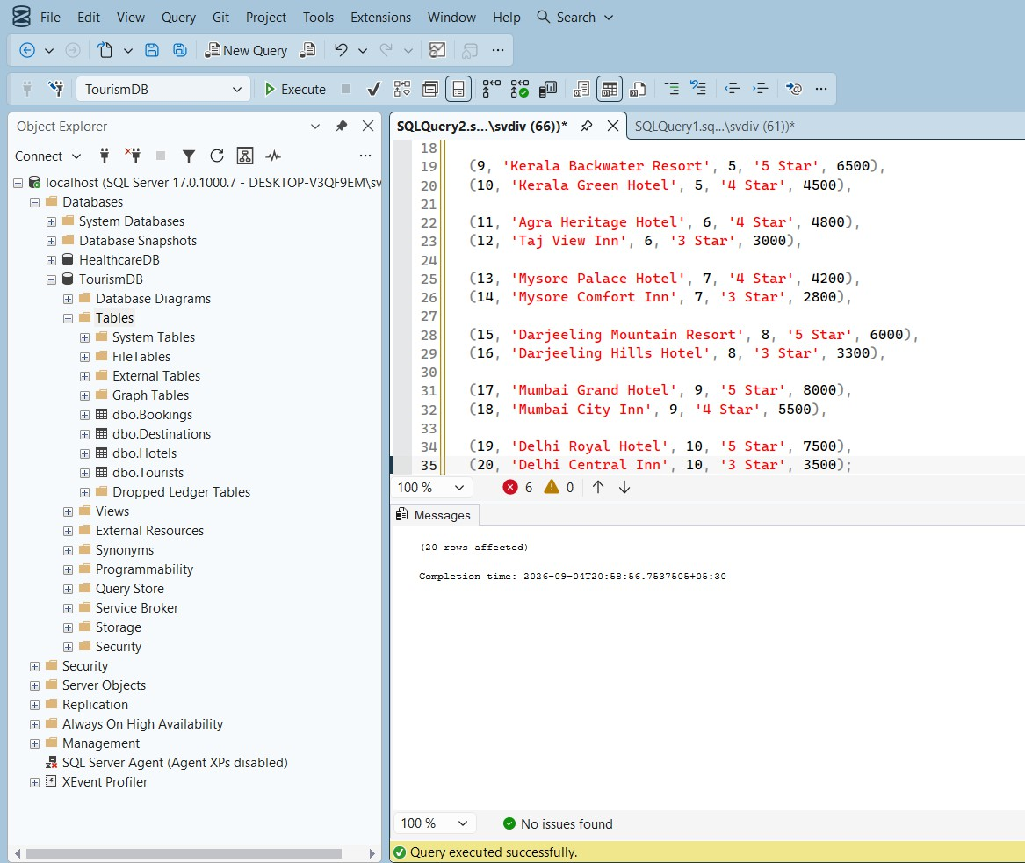
SQL SERVER DATABASE CREATION


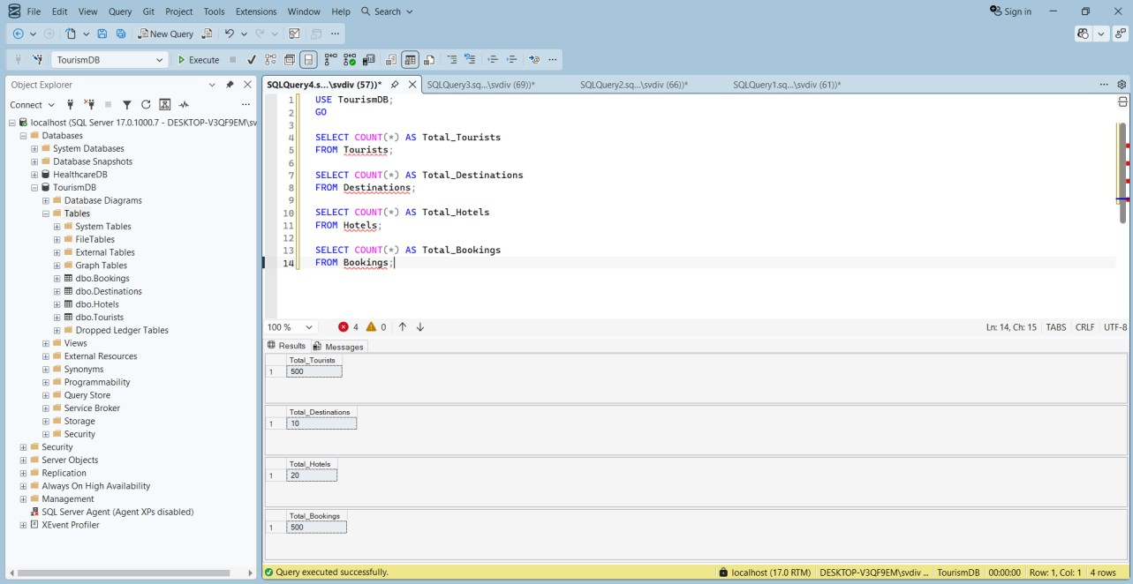
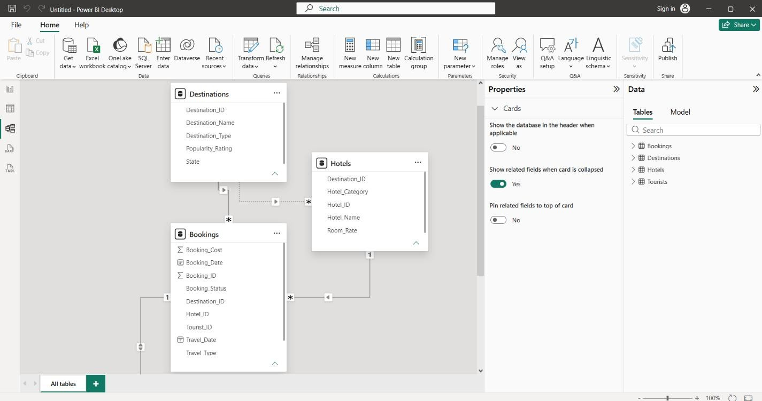


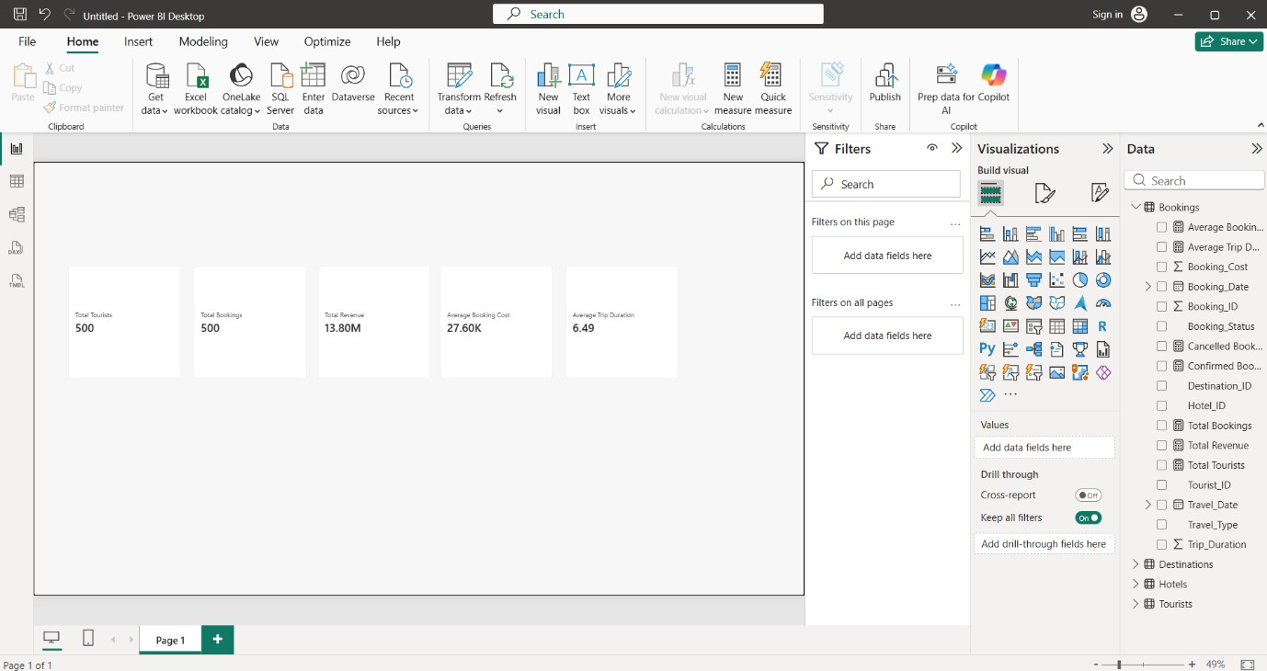
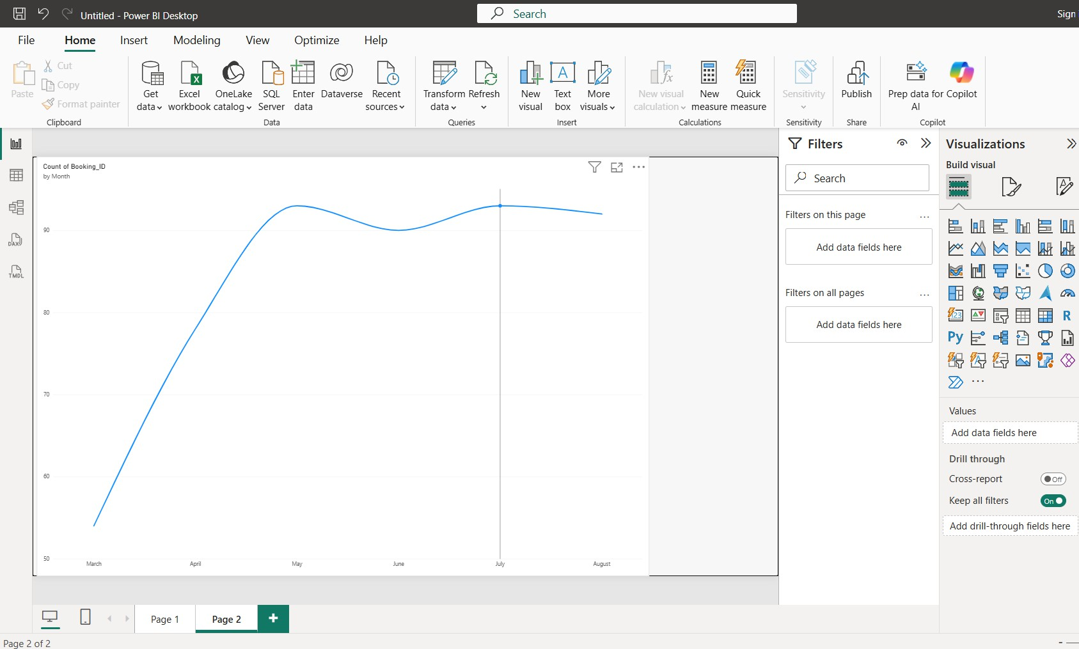
POWER BI DASHBOARD


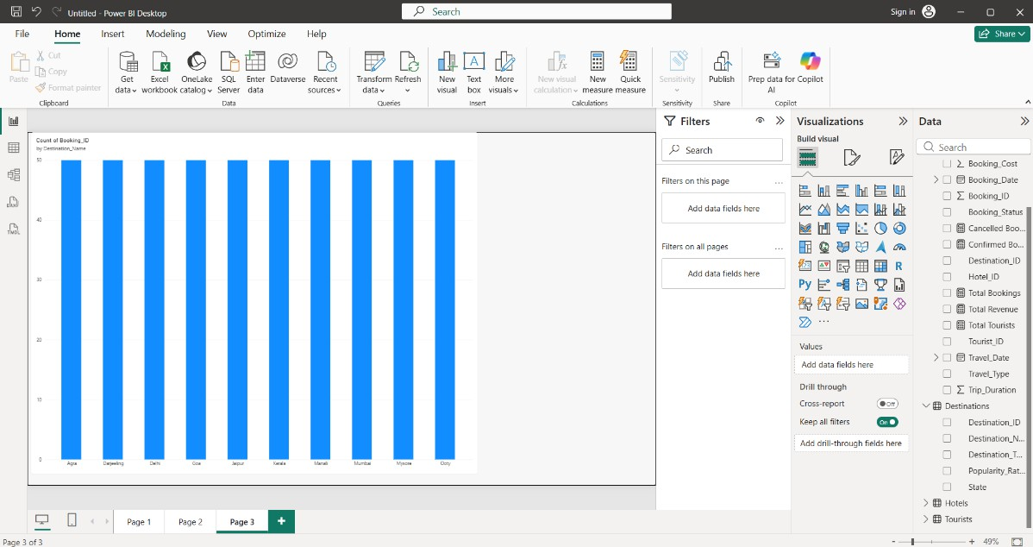
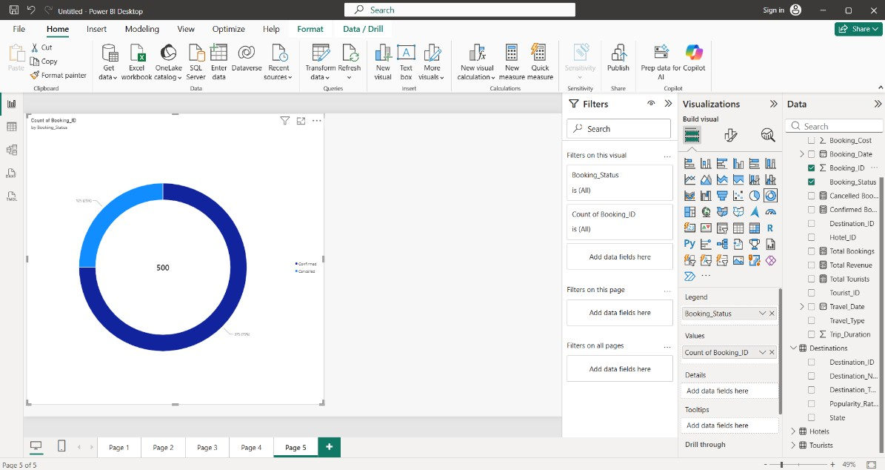
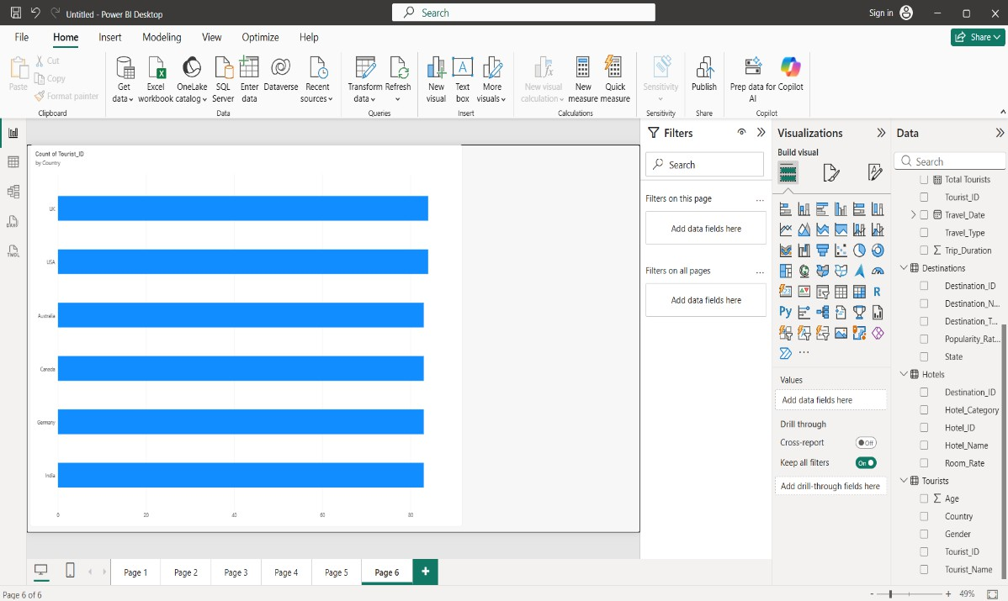


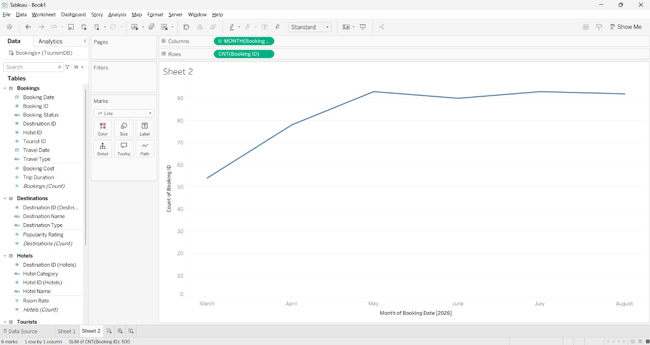
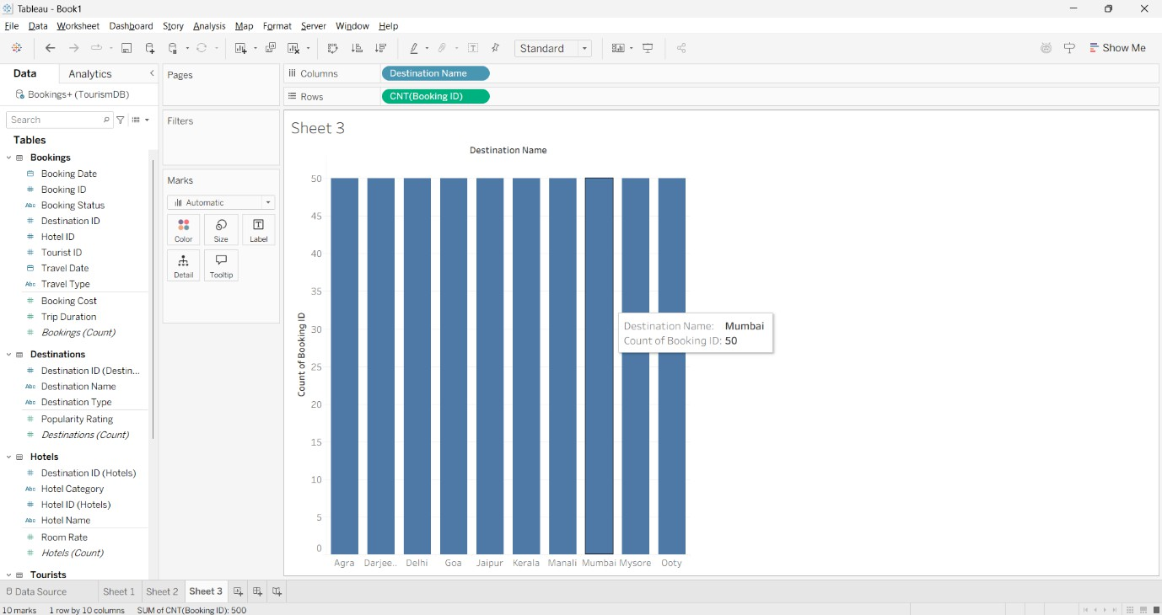
TABLEAU DASHBOARD

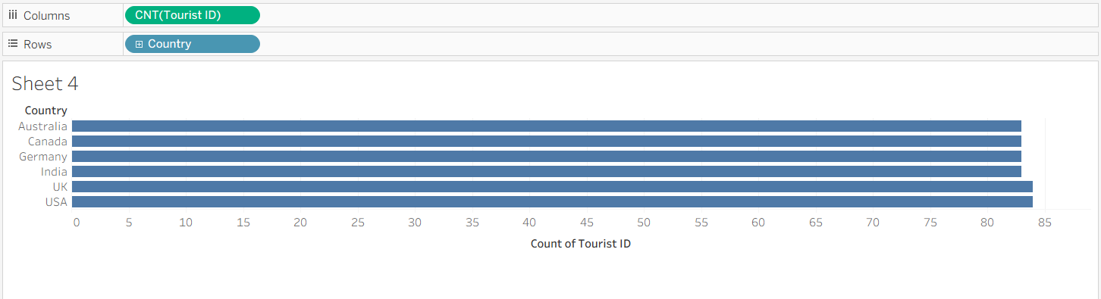

RESULT

